**Task 5**

**1. Task Description :**

Build a dynamic form that adds and removes input fields based on user input.

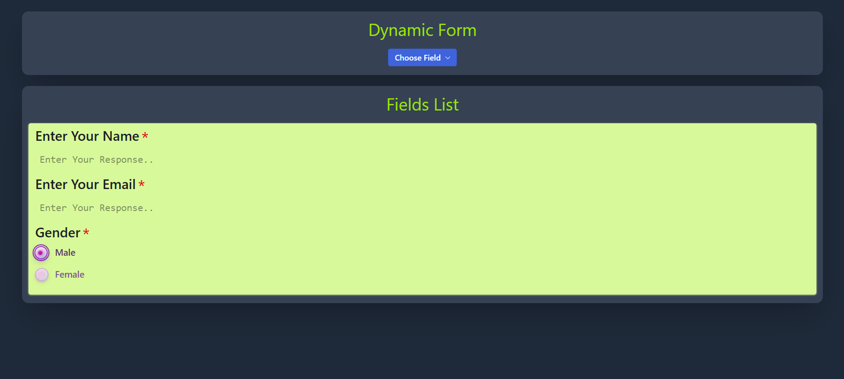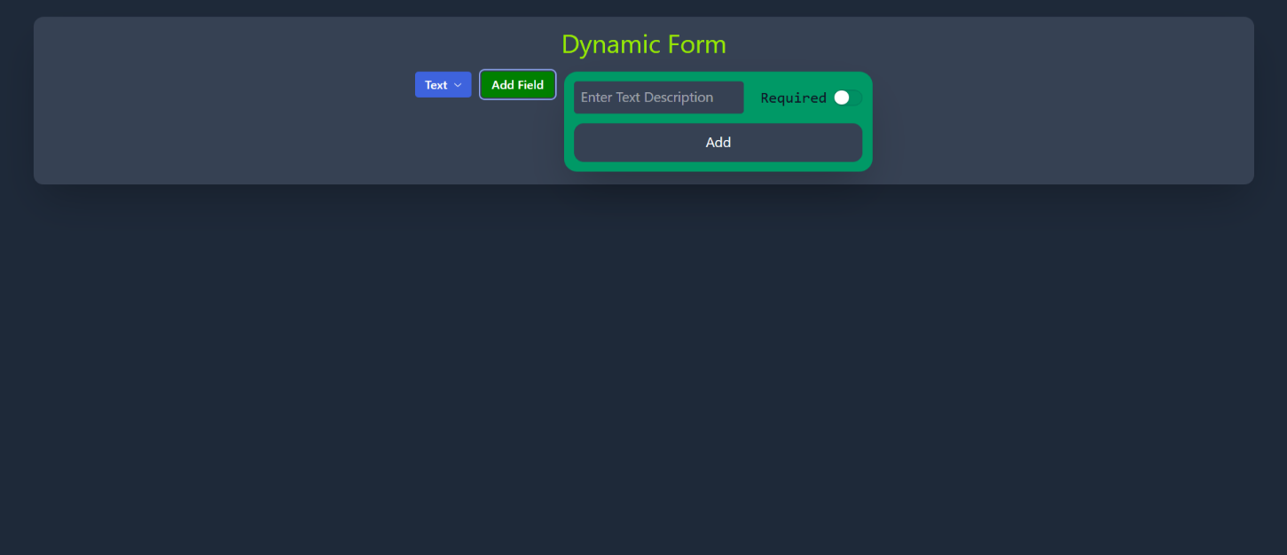**2. Screenshots :**

**3. Widgets/Algorithms Used in Task :**

* For Frontend Framework :- React.js
* For Styling And Animations :- Tailwindcss and framer-motion
* Components Library : [Radix-ui](https://www.radix-ui.com/)